Relieving Debt

Mortgage debt, car payments, loans, taxes, credit cards, child support, collection accounts, tickets, medical bills, utilities, and other things along the same lines, are all examples of debts...the types of items you can completely settle administratively. In legal and financial circles, whenever you get what we commonly refer to as a “bill” in the mail, it’s more accurately described as a “presentment”. Learn that word right now. Etch it in to your mind because that’s how those things should be referred to, and it’s also how we’re going to refer to them throughout the remainder of this manual. Most presentments come in the form of a top, statement section, with a perforated coupon at the bottom. That’s the part you’re typically told to detach and remit with you payment. You’ve probably seen a million of them. Perhaps you’ve noticed that at the bottom of these “coupons” is a bar code, or, strings of numbers that look mysteriously similar to routing and account numbers, like on the bottom of a check. Please understand that these “coupons”, even if they don’t have the strings of numbers or a bar code, although most do, are actually checks themselves, and, if endorsed correctly, and sent to the correct offices of the IRS, will pay for the debt it was sent in reference to. Do we have your attention yet? Remember, many aspects of this process are going to sound profoundly magical, but this is all based on actual, factual law. So, to re-state it: the payment coupons you get on the bottom, top, or elsewhere on your billing presentments are actually checks you can use to pay the thing, no matter what the debt. Now, sometimes you get a “payment presentment”, maybe from a collection agency, or something, and it doesn’t have a coupon. It doesn’t matter. This process works on a napkin. What matters is how you endorse the thing with the right words, and where you send it. So, any presentment you get, claiming you owe them some sort of debt, can be endorsed and sent to 1 of 3 very specific offices of the IRS to be paid!

Go look at a bill. Study it. Look at the coupon. The thing is a check. It always has been. But, you haven’t known what to do with it, so you follow instructions, detach it, and send it in with another form of payment, which is unnecessary, but what everyone does! Have you ever been taught to do differently? You and I both know the answer is NO. Well, as of right now, you’ll no longer be able to use that as a crutch or excuse because you’re being taught the truth. But, don’t feel weird because you’re just hearing about this now. This is well hidden information and has only come about by a tremendous amount of research, trial and error, and faith. A lot of smart people have been working on this for many years, and it’s finally gotten to a point where it works. This process was born out of utter frustration and has proven itself to be the answer that just about everyone wants, needs, and deserves. So, now you know that when you get a presentment (bill), that you can do something to it and send it somewhere to get taken care of. Let’s talk about what you do, OK? Each payment presentment you get needs to be handled in 2 different parts. The combination of the 2 constitutes full and proper endorsement, which allows the IRS to do what it needs to do with it upon receipt. If any aspect of either of the 2 parts to the endorsement are incomplete or incorrect, it won’t work and you’ll have to do it again.

ENDORSEMENT PART #1 Endorsement Part #1 involves doing what is called a “banker’s acceptance”. An example banker’s acceptance : Accepted for value Exempt from levy John Q. Doe January 01, 2013 Exemption ID #123456789 Deposit to United States Treasury and charge the same to JOHN Q. DOE 123-45-6789
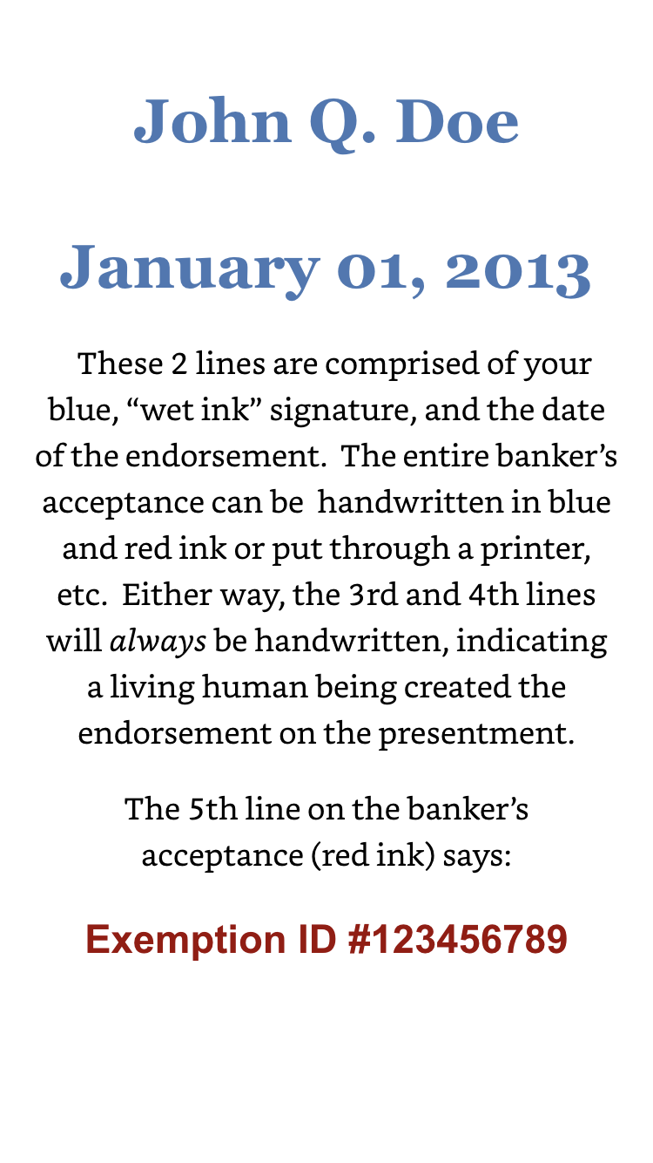

Of course, that’s an example. A real banker’s acceptance would include your information, which is key. Certain words are in red ink, while other words are in blue. There’s a reason for this. The actual color doesn’t matter as much as the fact that it’s a color other than black. If you were to use black ink, it could make the thing look like a copy, which is what we don’t want. Using colored ink makes it clear that the endorsement on the presentment is an original, so keep that in mind. Red is typically used because it stands out so well, while the parts done in handwriting typically work best in blue ink. When it comes to your signature, making it evident that it’s an original, in “wet ink”, is essential, because that’s the source of all new money - your signature.

So, the first line of the banker’s acceptance (red ink) says: Accepted for value This indicates that you’re accepting the value indicated on the presentment, whether it is $400.00 or $200,000.00. The 2nd line on the banker’s acceptance (red ink) says: Exempt from levy This indicates that you, the human being, are exempt from these types of claims of financial indebtedness. Remember, this is all part of government protocol and has been for nearly 80 years. The 3rd and 4th lines on the banker’s acceptance (blue ink) say: John Q. Doe January 01, 2013 These 2 lines are comprised of your blue, “wet ink” signature, and the date of the endorsement. The entire banker’s acceptance can be handwritten in blue and red ink or put through a printer, etc. Either way, the 3rd and 4th lines will always be handwritten, indicating a living human being created the endorsement on the presentment. The 5th line on the banker’s acceptance (red ink) says: Exemption ID #123456789

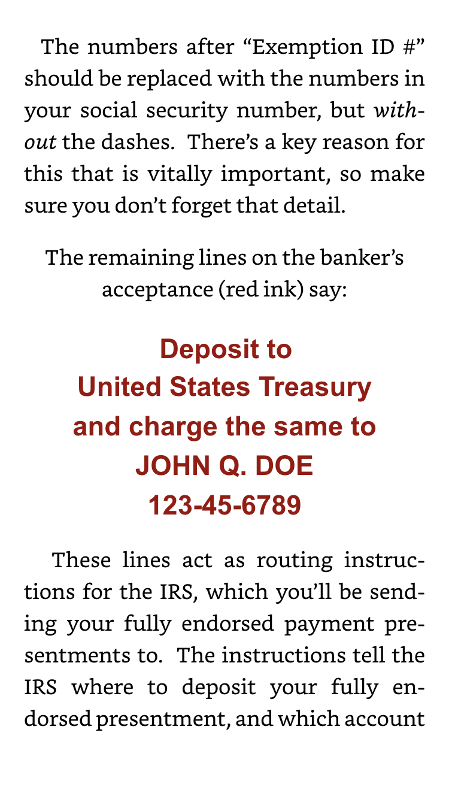

The numbers after “Exemption ID #” should be replaced with the numbers in your social security number, but without the dashes. There’s a key reason for this that is vitally important, so make sure you don’t forget that detail. The remaining lines on the banker’s acceptance (red ink) say: Deposit to United States Treasury and charge the same to JOHN Q. DOE 123-45-6789 These lines act as routing instructions for the IRS, which you’ll be sending your fully endorsed payment presentments to. The instructions tell the IRS where to deposit your fully endorsed presentment, and which account to draw the “funds” from, or “charge the same to”. That account is your name in all capital letters, followed by your social security number WITH dashes in it. Again, remember that the banker’s acceptance provided here is for example, so make sure to use your own, correct information when doing it yourself. That being said, your correctly formatted banker’s acceptance is what directs the IRS to specifically do “with what”, “for what”, and for “how much”. This kind of thing works, and your understanding will grow over time. The history, facts, and law have all been in place here for a long time, so know that you don’t have to know all of the deeper aspects to get out of debt, once and for all.

Now, Endorsement Part #1, whether fully handwritten, stamped, or printed‐out, will be placed at a 45 degree angle above the coupon, and repeated on any additional sides or pages that have additional writing or printing on it. For example, you might get a cell phone bill, and the 1st page is a statement at the top, with a coupon at the bottom. It may then have 3 more front‐and‐back pages detailing your call history and usage. Each page and side will need the banker’s acceptance written or printed on it, always at a 45 degree angle. If you use a printer for the banker’s acceptance, most word processing programs have a “rotate” feature, so it’s simple enough to achieve the 45 degree angle effect. Also, there are many time‐saving benefits to using a printer, or custom‐made stamp, especially if you have more than a few payment presentments to do in 1 sitting. But remember, the banker’s acceptance is only 1/2 of what needs to be done to each presentment in order to consider it fully and properly endorsed and ready to be sent to the IRS for payment.

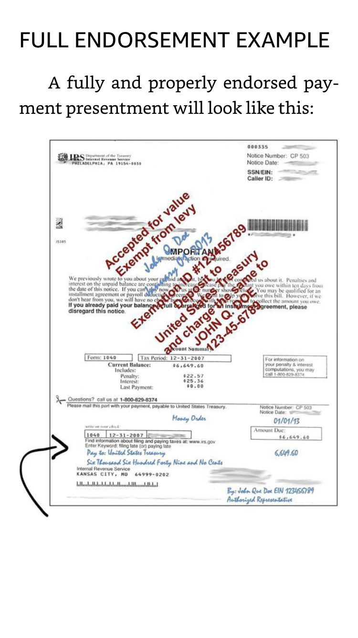
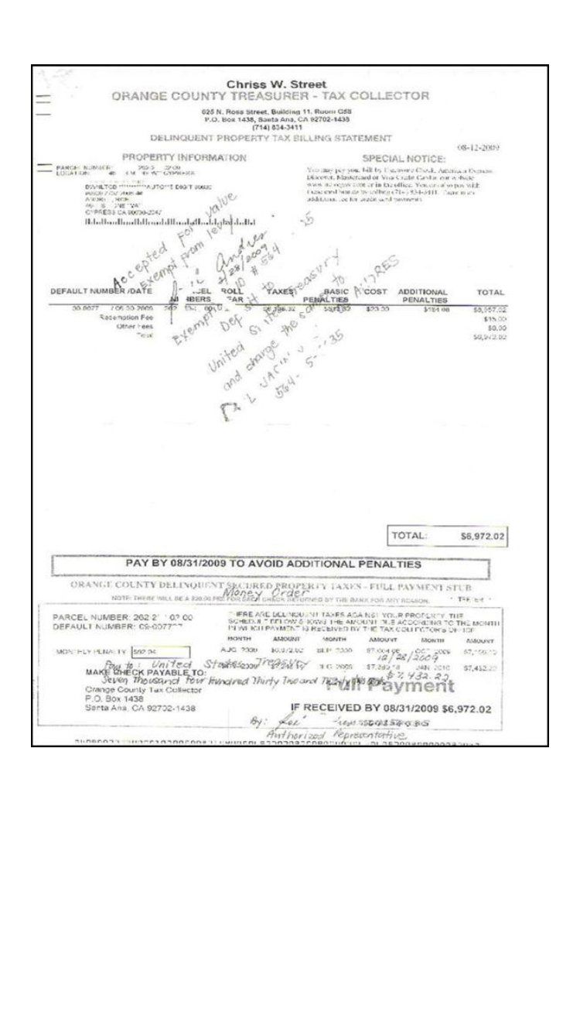

ENDORSEMENT PART #2 Endorsement Part #2 involves creating what we call a “money order” on the coupon itself. A handwritten money order (blue ink) looks like this: The wording will be fit within any available white space on the coupon, but try to keep the order and layout of the information as best you can. Of course, you’ll replace the example information with the actual amount of the payment presentment you’re endorsing, along with whatever your name and social security number without dashes actually is. Remember, the entire money order portion, or Endorsement Part #2, is done in blue, “wet ink”. A signed, handwritten money order on a payment presentment, in force and effect, charges that coupon (check) up as actual, useable currency. Now, not all coupons are created equally. Some have very little white space, while others have a lot. Like we said earlier, sometimes, the presentment doesn’t even have a coupon. Whether a presentment has a coupon or not, including a handwritten money order on the thing is a must. If a coupon is present, squeeze in the wording as described earlier. If there’s not a coupon present, find any white space on the collections letter or other debt presentment and write-in a money order. Additionally, and this is very important, in all cases, whenever a money order is created, you must endorse the back of it with your blue, “wet ink” signature in the same form and fashion as you would a check. Just turn the presentment over and sign your name on the side, like endorsing a check. No other numbers or wording should go on the back, other than your signature.

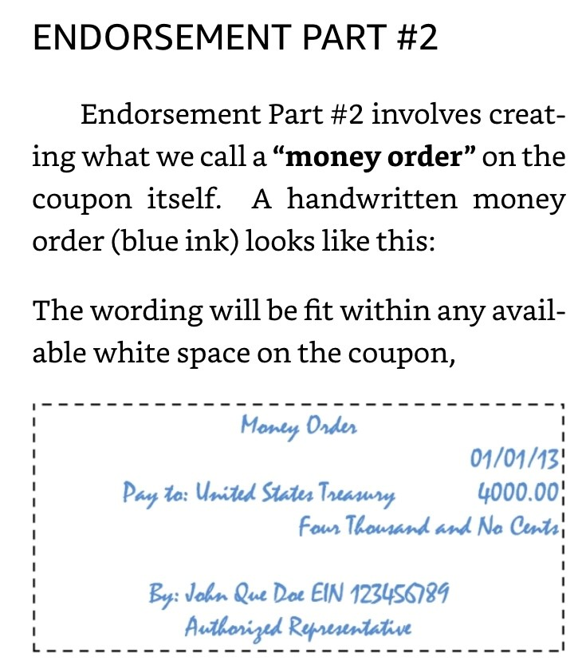

When a payment presentment is fully and properly endorsed with both Endorsement Part #1 and Endorsement Part #2, and then when it’s sent to 1 of the 3, specific offices of the IRS, that debt will be paid-off!

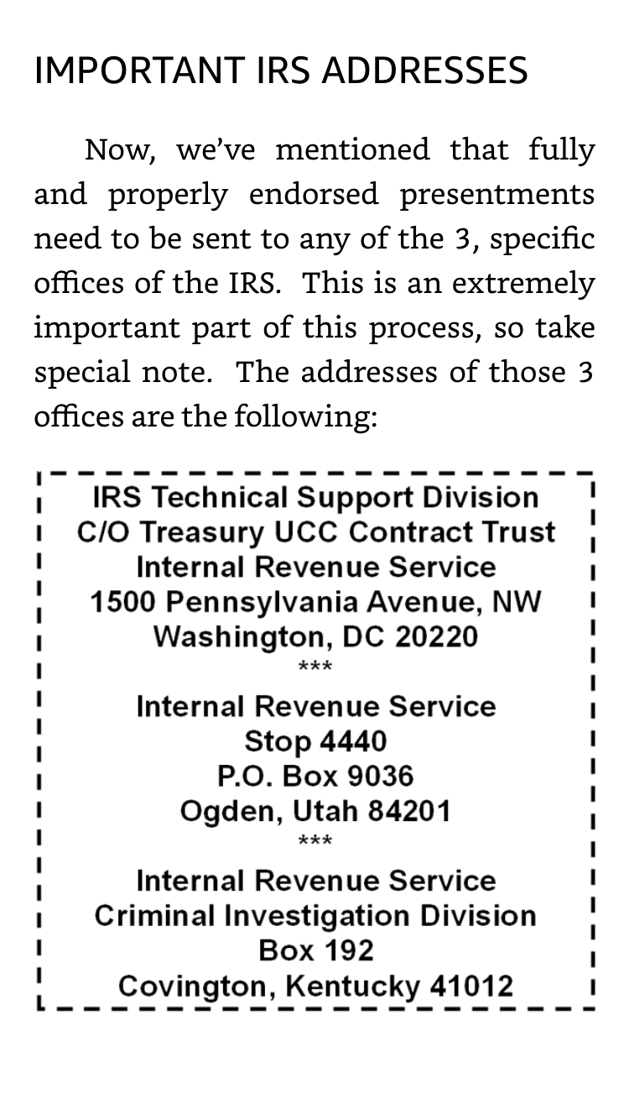
Your presentments shouldn’t be sent anywhere else, as they’ll be ignored and you’ll have wasted your time. These 3 specific offices of the IRS are the only ones equipped to properly handle what you send to them. Hopefully, over time, more IRS offices will open‐up across the nation that know how to handle our fully and properly endorsed presentments, but until then, only send them to the 3 addresses above, on a rotational basis. A common mistake being made is sending everything to an IRS office not listed here, so keep this important step firmly in mind. At this point, it might be that this seems so completely unreal that you think it just couldn’t possibly be true. Perhaps you feel that everybody would know about this already if it was real. I mean, it really is kind of a fantastic notion to think that you could just write some stuff on your bills and have them be paid.

